**Sample Simulation of Lab 3**

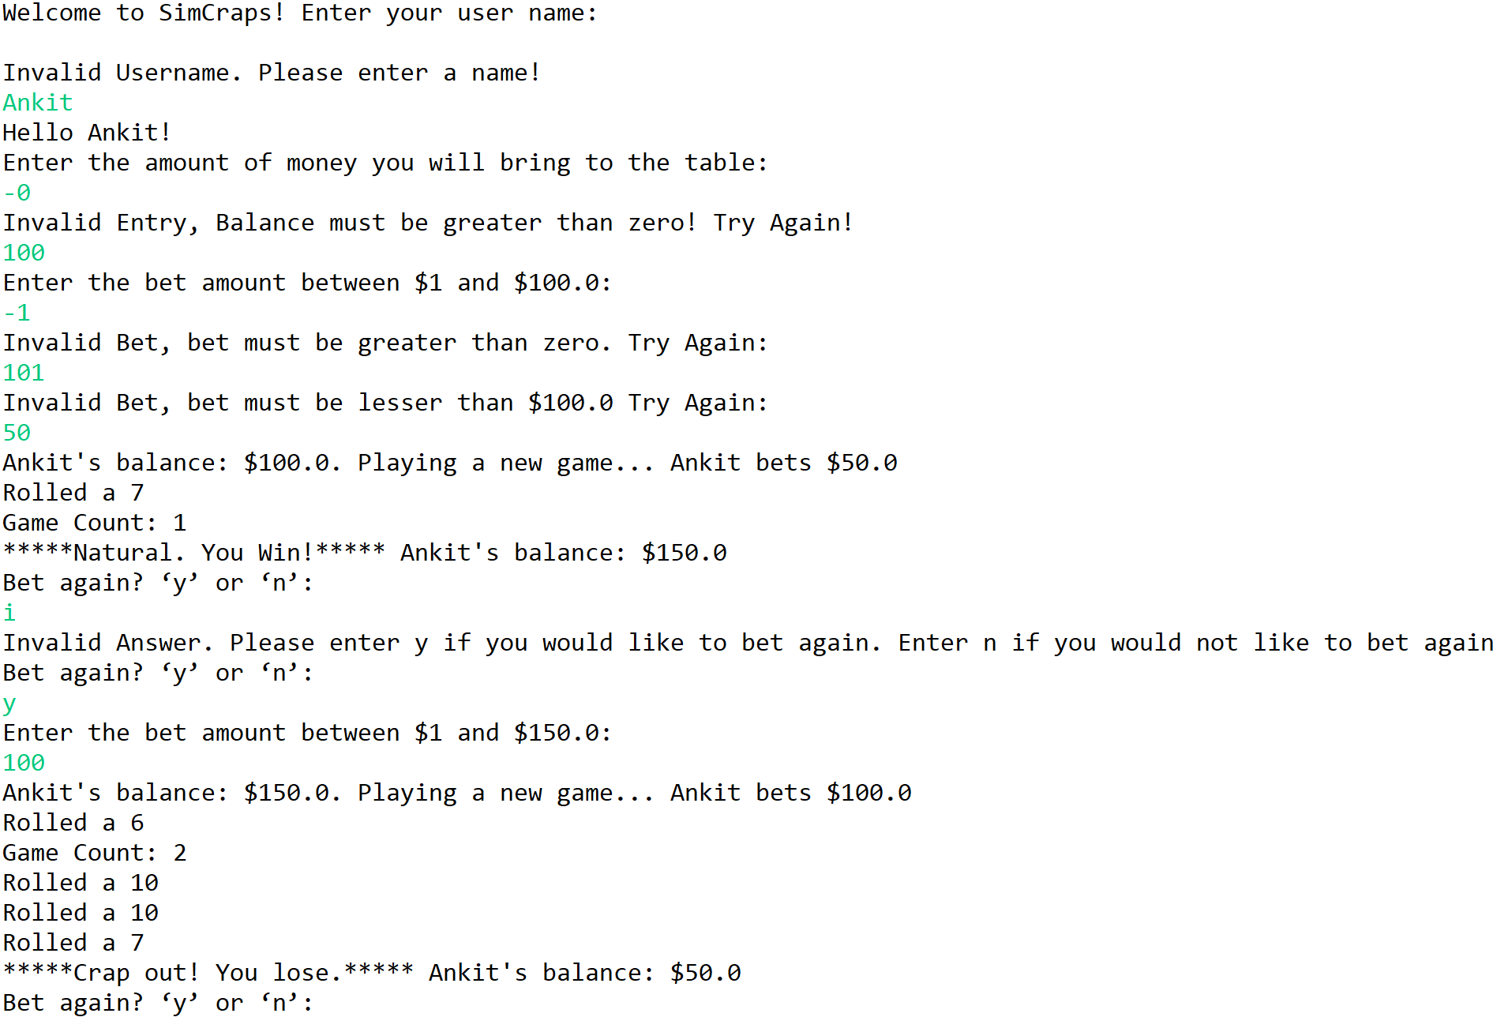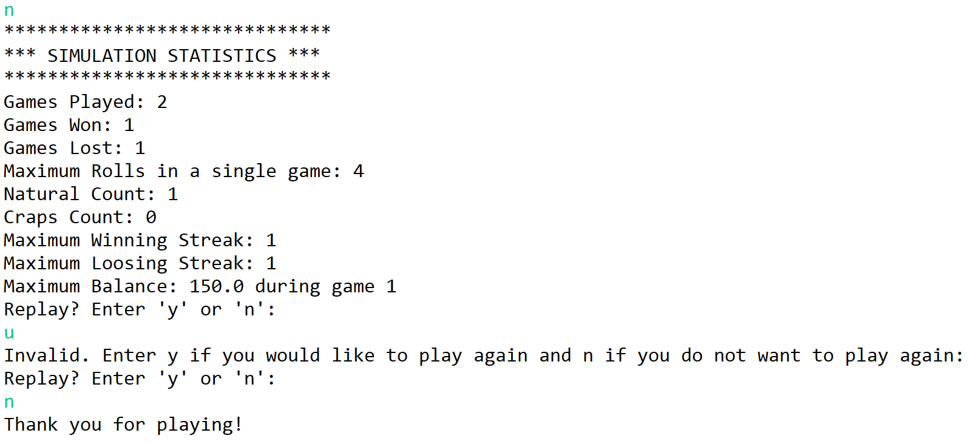

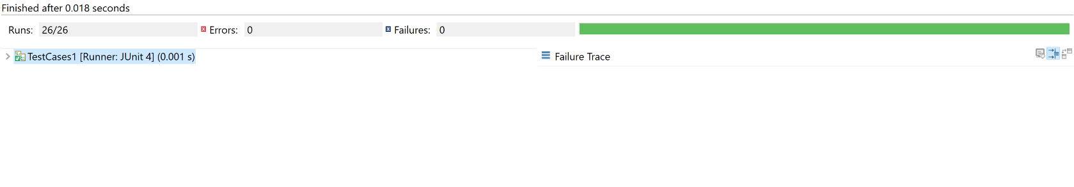**Sample JUnit Testing Result**